[Name]
[Company Name]
[Street Address]
[City, ST ZIP Code]

Dear [Name],

Thank you for considering KMH Fleet Solutions. for your material handling equipment needs. We are pleased to offer the following for your review.
Viper Forklift – FY25BCS
Quantity: | 1 | Year: | 2019
Capacity: | 5000 lbs.
Tires: | Pneumatic
Lowered Mast Height: | 85”
Raised Mast Height: | 189”
Mast: | 3 Stage Mast - Sideshift
Fork Length: | 48”
Engine: | GM / PSI 3.0 Engine
Fuel: | Dual Fuel
Counterweight: | Box Car Counterweight For Tight Turning Points
Features: | - Load Backrest  - Backup Alarm  - Lights  - Turn Signals

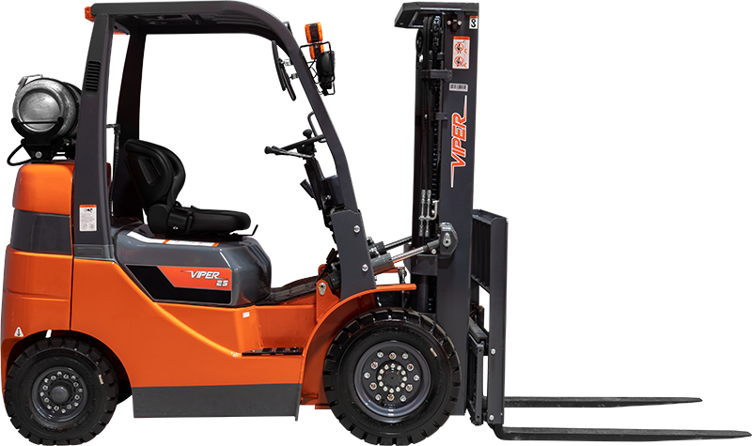
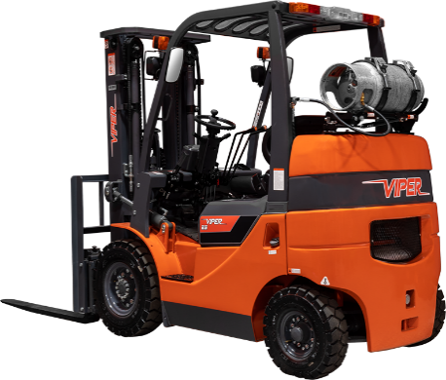 | 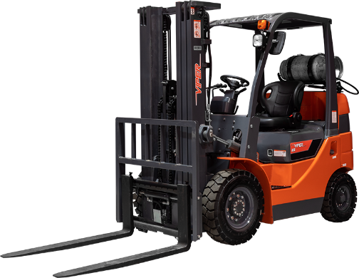 | 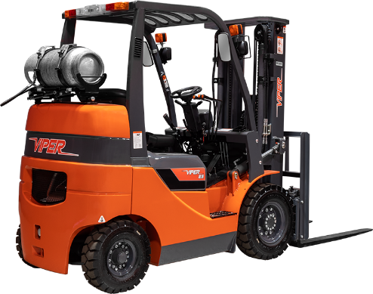

Investment Price:
Grand Total:  Plus Applicable Tax | $XXXX.XX

Finance Options: (Rates are per month / per unit and do not include sales tax)
60 Month - Fair Market Value Lease FMV | $XXX.XX / Month
60 Month - $1 Buyout Option | $XXX.XX / Month

TERMS & CONDITIONS
The proposal in this quote is property of KMH and is confidential and proprietary. Unauthorized disclosure could be harmful to KMH and by acceptance, prospective buyer agrees not to publish, copy or reproduce the contents without the express written consent of KMH, [Company Name] will not use such information for any other purpose than for the consideration of a KMH supplied system and will return any or all information contained herein to KMH upon request.

ACCEPTANCE AS CONTRACT OF SALE
Warranty: [Enter info here]
Delivery: [Enter info here]
FOB: [Enter info here]
Terms: [Enter info here]

Accepted By: Signature: [Company Name]  Title Date  Purchase Order Number | KMH Representative  Title Date  Purchase Order Number

[KMH Rep Name Here] – KMH Fleet Solutions
[Title and Phone Number]
[Email]

TERMS AND CONDITIONS

- This proposal, including the specifications, and terms and conditions stated herein, constitutes an offer by seller which may only be accepted on exact terms as set forth. This quotation supersedes any prior proposal with reference to the same subject. No reference herein to the purchaser’s inquiry shall in any way modify the terms and conditions hereof. Purchaser shall issue its own purchase order and such document shall in no way bind seller to any different or additional terms and conditions other than as set forth herein. Purchaser can acknowledge acceptance of seller contract in lieu of any purchase order. The offer may be withdrawn by seller at any time prior to purchaser’s acceptance. The proposal is good for a period of 30 days from the quotation date and if acceptance after that date, seller to furnish written consent of same.
- The title to the material and equipment provided by the seller shall remain with the seller and shall vest in purchaser only upon the payment in full to the seller of the purchase price herein specified, whether directly by buyer or another financial entity. Until such time as purchase price is paid in full, purchaser shall, at all times, keep the material and/or equipment on its premises, nor shall any said material or equipment be transferred, pledged, or disposed of by purchaser.
- The price stated in this proposal assumes that seller will be able to proceed on a continuous basis of manufacturing, delivery, and installation without delays. The seller assumes responsibility to deliver any equipment as specified in this proposal. Additionally, any changes in the specifications or configurations, or delays subsequent to this proposal that are requested by the buyer after an order has been placed shall constitute an additional expense due to the seller. No action shall be taken by the seller until written change order acceptance has been signed or issued by both the purchaser and seller.
- Any tax, permits or fees now hereafter imposed by a federal, state, or municipal government or agency thereof, shall be the responsibility of the buyer. This is applicable to any equipment and or services covered hereby.
- Unless otherwise stated in this proposal, the terms of payment shall be – 30% Down Payment and 70% upon shipment on materials and new equipment orders. 30% down and 60% upon shipment and 10% upon completion of installation on quotes with installation. Invoices that are not paid from the due dates will be subject to 1-1/2% interest per month until paid in full.
- In no event shall the seller be liable hereunder or otherwise for the loss of profits or indirect, incidental or consequential damages.
- The lessee agrees to comply with and conform to all municipal, state, and federal laws relating to the operation of said machinery and to pay all costs and expenses or every character occasioned by or involving the use or operation of the machinery and to pay all legal assessments, taxes, or public charges, either local, municipal, state or federal, which may be levied upon such equipment while in the possession of the lessee. The lessee is to pay the personal tax levied against the machinery rented when said machinery is delivered within the home state of the lessor, as in this case the lessor may pay his own personal property tax and property segregate to the lessor’s equipment and such segregation have same marked or otherwise identified as property of the lessor’s at all times. The lessor would then send the lessee an invoice for the amount of property tax levied and paid by the lessor.
- There shall be no postponement or cancellation of this order or contract unless by mutual agreement. In the event of cancellation by mutual agreement the buyer shall be liable for any and all actual expenses incurred by KMH, which could include but is not limited to, cancellation or restocking fees, carrying costs, supervision, labor and material delivered or in process at the time of cancellation.
- Seller agrees to provide a competent person at the job site to supervise and direct any work. No change in this person will be made unless submitted to the approval of both seller and purchaser.

