Customer Name
Company Name
Address
City, State, Zip

Dear Customer Name,

Thank you for considering KMH Systems, Inc. for your material handling equipment needs. We would take this opportunity to quote you on an operator training program for your plant, specifically relating to Forklift Regulatory Compliance 29 FR 1910.178:

The Forklift / Powered Industrial Truck Safety Training Consists of Three Elements:
Formal | Consists of General, Classroom-type involving Viewing DVD; Estimated Time: 90 minutes
Practical Training | Includes site-specific, hands-on training
Visual Evaluation | Actual visual evaluation of the operator’s skills

Features of the Program will provide the following basics in English:
- Overview of 1910.178
- Operator Safety
- Equipment Inspection
- Forklift Stability
- Carbon Monoxide
- Propane Safety
- Pedestrians
- Ramps
- Workplace Obstacles

*These above topics must be covered when training or evaluating a forklift operator*

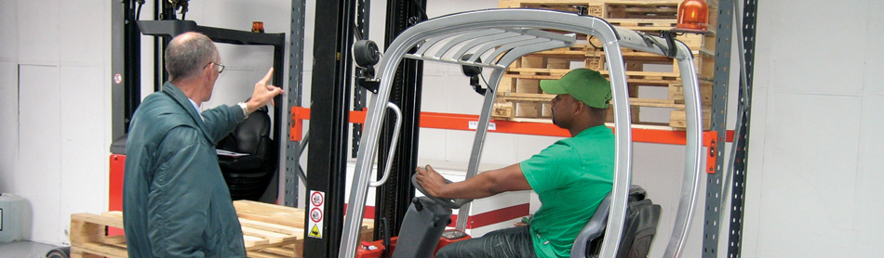

Please Use The Following Checklists To Document That Employees Have Been Trained
and/or Evaluated In All The Topics Listed Below…
Workplace-Specific Topics:
- Surface conditions where the vehicle will be operated.
- Composition of loads to be carried and load stability.
- Load manipulation, stacking, and un-stacking
- Pedestrian traffic where the vehicle will be operated.
- Narrow aisles and other restricted places where the vehicle will be operated.
- Ramps, portable and other sloped surfaces that could affect the vehicle’s stability.
- Closed environments and other areas where insufficient ventilation or poor vehicle maintenance could cause a buildup of carbon monoxide or diesel exhaust.
- Hands-on demonstration using the type of vehicle that the operator will actually be using.
General Forklift Topics:
- Operating instructions, warnings and precautions for types of industrial trucks the operator will be authorized to operate.
- Differences between the forklift and an automobile.
- Vehicle controls and instrumentation:
Where they are located, what they do and how they work.
- Engine or motor operation.
- Steering and maneuvering.
- Visibility (including restrictions due to loading).
- Fork and side shifter attachment adaptation, operation and use limitations.
- Vehicle capacity.
- Vehicle stability.
- What to do in case of a tip over
- Vehicle inspection and maintenance that the operator will be required to perform.
- Refueling and/or charging and recharging the batteries.
- Operating limitations.
Other operating instructions, warnings, or precautions listed in the operator’s manual.

Investment Price:
Weekday Training Session Price, up to 5 People: |  | Price.
6-10 People | An additional $95.00 for each person
11+ People | An additional $80.00 for each person
*Plus travel time to your location, if applicable*

Additional Notes
TRAINING DATE: TBD
TRAINING SITE: Our location or your location
Trainer / Training Acceptance

Name of Trainer: Bill Spalding

Each trainer, after successfully completing training, will receive a new license and a certificate of completion. Student testing and evaluation papers will be left with you for record keeping.

Thank you for this opportunity to quote your training needs. We appreciate your business. If you have any questions please give us a call.
Accepted By: Signature: Company Name  Title Date  Purchase Order Number | KMH Systems Representative  Title Date  Purchase Order Number

William Spalding – KMH Systems, Inc.
Corporate Trainer – 574-876-4792
Email – bspalding@kmhsystems.com

TERMS AND CONDITIONS

- This proposal, including the specifications, and terms and conditions stated herein, constitutes an offer by seller which may only be accepted on exact terms as set forth. This quotation supersedes any prior proposal with reference to the same subject. No reference herein to the purchaser’s inquiry shall in any way modify the terms and conditions hereof. Purchaser shall issue its own purchase order and such document shall in no way bind seller to any different or additional terms and conditions other than as set forth herein. Purchaser can acknowledge acceptance of seller contract in lieu of any purchase order. The offer may be withdrawn by seller at any time prior to purchaser’s acceptance. The proposal is good for a period of 30 days from the quotation date and if acceptance after that date, seller to furnish written consent of same.
- The title to the material and equipment provided by the seller shall remain with the seller and shall vest in purchaser only upon the payment in full to the seller of the purchase price herein specified, whether directly by buyer or another financial entity. Until such time as purchase price is paid in full, purchaser shall, at all times, keep the material and/or equipment on its premises, nor shall any said material or equipment be transferred, pledged, or disposed of by purchaser.
- The price stated in this proposal assumes that seller will be able to proceed on a continuous basis of manufacturing, delivery, and installation without delays. The seller assumes responsibility to deliver any equipment as specified in this proposal. Additionally, any changes in the specifications or configurations, or delays subsequent to this proposal that are requested by the buyer after an order has been placed shall constitute an additional expense due to the seller. No action shall be taken by the seller until written change order acceptance has been signed or issued by both the purchaser and seller.
- Any tax, permits or fees now hereafter imposed by a federal, state, or municipal government or agency thereof, shall be the responsibility of the buyer. This is applicable to any equipment and or services covered hereby.
- Unless otherwise stated in this proposal, the terms of payment shall be – 30% Down Payment and 70% upon shipment on materials and new equipment orders. 30% down and 60% upon shipment and 10% upon completion of installation on quotes with installation. Invoices that are not paid from the due dates will be subject to 1-1/2% interest per month until paid in full.
- In no event shall the seller be liable hereunder or otherwise for the loss of profits or indirect, incidental or consequential damages.
- The lessee agrees to comply with and conform to all municipal, state, and federal laws relating to the operation of said machinery and to pay all costs and expenses or every character occasioned by or involving the use or operation of the machinery and to pay all legal assessments, taxes, or public charges, either local, municipal, state or federal, which may be levied upon such equipment while in the possession of the lessee. The lessee is to pay the personal tax levied against the machinery rented when said machinery is delivered within the home state of the lessor, as in this case the lessor may pay his own personal property tax and property segregate to the lessor’s equipment and such segregation have same marked or otherwise identified as property of the lessor’s at all times. The lessor would then send the lessee an invoice for the amount of property tax levied and paid by the lessor.
- There shall be no postponement or cancellation of this order or contract unless by mutual agreement. In the event of cancellation by mutual agreement the buyer shall be liable for any and all actual expenses incurred by KMH, which could include but is not limited to, cancellation or restocking fees, carrying costs, supervision, labor and material delivered or in process at the time of cancellation.
- Seller agrees to provide a competent person at the job site to supervise and direct any work. No change in this person will be made unless submitted to the approval of both seller and purchaser.

